**NAMA : SHINTIA JULI RAHMAWATI**

**NIM : 1120101896**

**MAPEL : FRONTEND DEVELOPMENT**

**TUGAS PERTEMUAN 5**

**STYLING**

**LARGE METHOD**

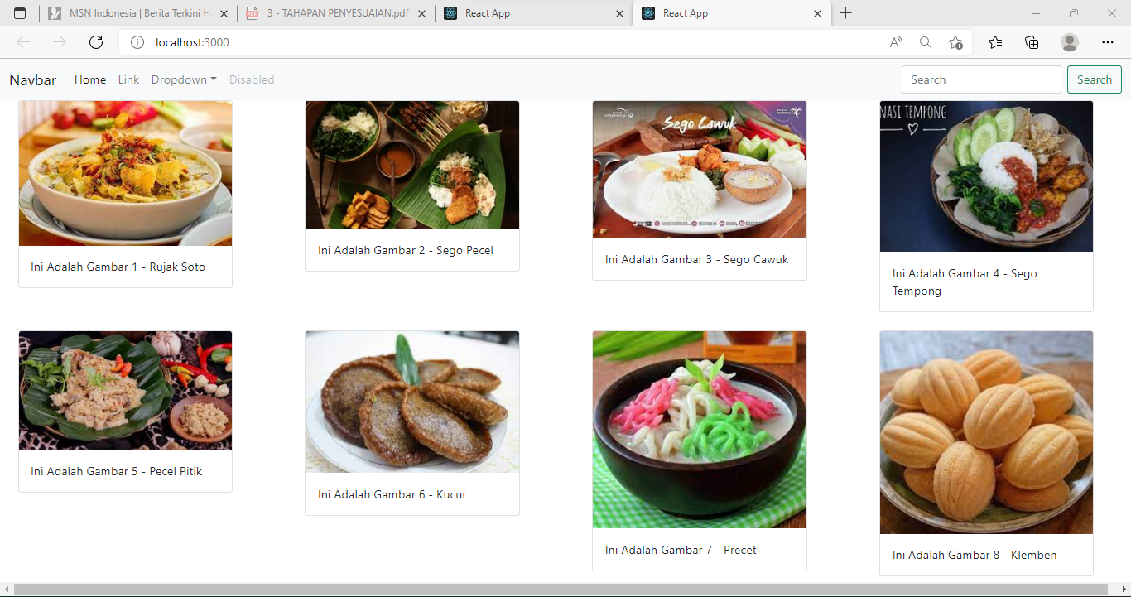

**MEDIUM METHOD**

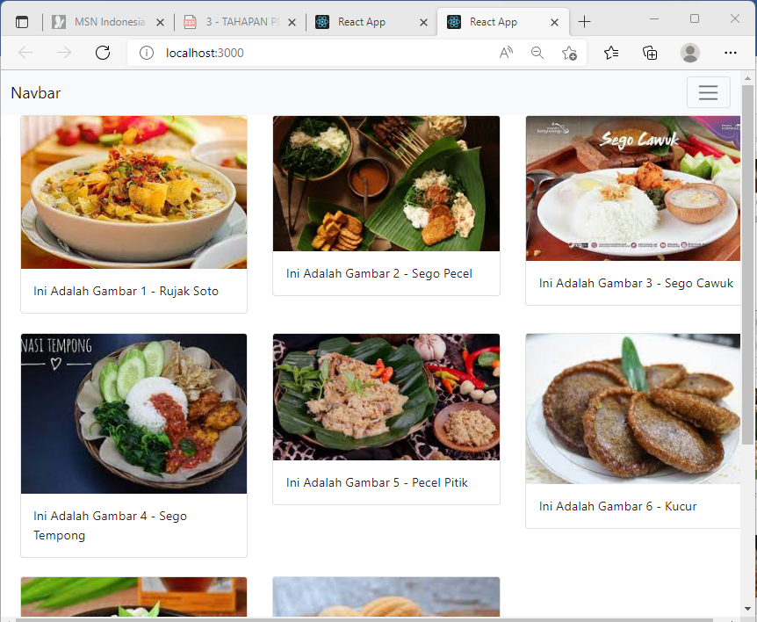

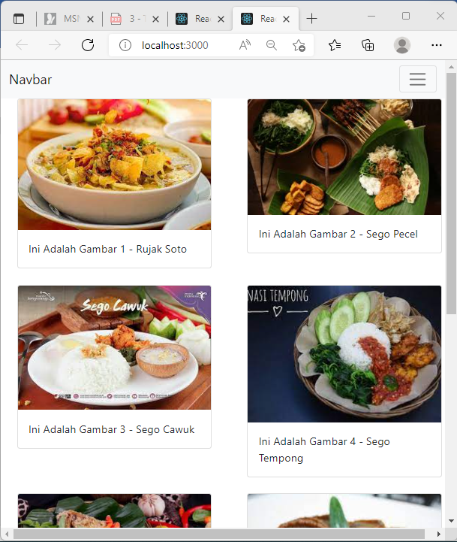**SMALL METHOD**